APPLICATION FOR SITE
PLAN APPROVAL

NOTE: APPLICATION WILL ONLY BE PROCESSED WHEN:

- APPLICATION FEE AND DEPOSIT IS PAID:

$500.00 – NEW APPLICATION
$200.00 – REVISED APPLICATION
Note: Professional fees and peer review costs will be the responsibility of the applicant on a cost recovery basis invoiced by the municipality.

- COMPLETED APPLICATION FORM IS SUBMITTED.

- TEN (10) COPIES OF FOLDED SITE PLANS ARE SUBMITTED.

(MAXIMUM FOLDED SIZE OF DRAWINGS TO BE 8 ½” X 14”)

APPLICATION FOR SITE PLAN APPROVAL
For Use By Municipality

Application number: | Date Received:
Roll No: | Meeting Date:

A) Applicant Information – Applicant is the owner; or, the authorized agent of the owner. (If the corporation of partnership, name of person applying on its behalf)
Last Name |  | First Name |  |  | Middle Initial
Corporation or Partnership (if applicable)

Street Number | Street Name |  | Unit number: | Lot/Conc.
Municipality | Province |  | Postal Code | Email
Telephone | Fax Number (optional) |  | Cell Number (optional)

B) Owner Information (if different from applicant)
Last Name |  | First Name |  |  | Middle Initial
Corporation or Partnership (if applicable)

Street Number | Street Name |  | Unit number: | Lot/Conc.
Municipality | Province |  | Postal Code | Country
Telephone | Fax Number (optional) |  | Cell Number (optional)

C) Property Information
Street Address |  | Town
Legal Description

Proposed Use
New Floor Area | Existing Area (If Addition) | Total Floor Area

I hereby apply for Site Plan Approval and declare that the statements made on this application and the information contained in the accompanying plans is true. I understand that Site Plan Approval is required before any building permit can be issued.

________________________________ ____________________________________
Date Registered Owner or Authorized Agent
____________________________________
Name and Title (Print)

Applicant’s Name: _____________________________________________________________________

Site Location: __________________________

RP#: ___________________

Lot #: __________________

Required Site Plan Information | Yes | No
1. North Arrow
2. Benchmark Description and Reference to Geodetic Datum
3. Legal Description of Property
4. Existing and Proposed Lot Corner Elevations
5. Proposed Elevations at Corner of Structure
6. Percent Grades Along Lot Lines
7. Finished Floor Elevations and/or Top of Foundation Elevation
8. Extent of Proposed Site Grading
9. Drainage Pattern with Flow Arrows and Swale Details
10. Driveway and Parking Facilities Shown on Grading Plan with
Proposed Grades and Percent Slopes
11. Paved Entrance Ramp
12. Slopes with Slope Ratio Indicated
13. Existing Centreline, Edge of Pavement and Ditch Elevations Indicated Along Frontage of Property
14. Legend
15. Scale of Drawing
16. Roof Drainage (eaves trough location and direction of outlet flows)

Remarks:
_____________________________________________________________________________________

_____________________________________________________________________________________

_____________________________________________________________________________________

_____________________________________________________________________________________

_____________________________________________________________________________________

Cc: ___________________________________ Prepared By: ____________________________

What is Site Plan Approval?

Site Plan Approval is a form of development control, authorizes under Section 41 of the Planning Act and enacted through the Town of Deep River Official Plan adopted by Bylaw Number 3-93 as amended. This means the Town has the authority to influence the design of certain types of development in addition to meeting requirements of the Town’s Zoning By-law and the Ontario Building Code.

Site Plan Control applies to all development within Deep River with the exception of single family dwellings; two-family dwellings; detached triplexes; buildings which are accessory to such dwellings; and farm buildings. Site Plan Approval is required prior to the issuance of a Building Permit for all developments, which are subject to site plan control, except those listed above and unless designated otherwise. (Site Plan Approval is required for a new building addition, change of land use or commercial parking lot). Please contact the Town to determine whether or not your development proposal requires Site Plan Approval.

A person applying for Site Plan Approval will submit clearly legible blueprints (not photocopies) of the following plans:

- A site plan
- A grading and servicing plan
- A detailed landscape plan
(The grading and servicing plan and the detailed landscape plan may be combined on one plan if the proposal is minor in nature and if information can be legibly presented)

Where required by the Town of Deep River, copies of the following plans:

- A perspective rendering
- Cross-section drawings
- Elevation drawings
- Floor plans

The above noted drawings must also be accompanied by both a completed Site Plan Application form and Site Plan Application fee. Site Plan approval may also include entering into a Site Plan Control Agreement and posting security for site works. Once all the required drawings, the application form and the application fee are received, the application can be processed.

The Purpose of Site Plan Approval

The purpose of Site Plan Approval is to allow the Town of Deep River and, where applicable, other jurisdictional agencies, to review the following;

- Overall site design
- The impact of the proposal on surrounding land uses
- Siting of structures and buildings (massing and conceptual design)
- The widening of public roads which abut the site
- Easements, access, parking, and loading facilities
- Grading and site drainage
- Provision for disposal of storm, surface, and waste water
- Landscaping and buffering; amenity areas
- Curbs, signs, walkways, lighting, fencing, storage of waste

The Town will review the application in consideration of internal functioning (i.e. parking, emergency vehicle access, traffic flow); aesthetic contribution, serviceability, energy efficiency, and spatial, aesthetic and functional relationships with adjacent properties.

Site Plan Control ensures that municipal requirements are met and helps to improve the quality and appearance of the development to everyone’s benefit.

Once you make formal application, it is your responsibility to contact the Town on the status of the proposal, and on any recommended changes or conditions required, until Final Site Plan Approval is received.

What is required for Final Site Plan Approval?

When the applicant’s drawings meet all of the applicable requirements, the final drawings will be stamped and recommended for approval. The owner may then be required to enter into a Site Plan Control Agreement with the Town and post security in an amount equal to 50% of the cost of site works up to a minimum of $1,000.00 and a maximum of $50,000.00 provided in a form acceptable to the Town. The agreement stipulates that the site is to be developed in accordance with the approved site plan and the posted security ensures that the applicant will do this, or the Town has the mechanism to complete the works, drawing upon the security. If the Site Plan Control Agreement and security is required, final Site Plan Approval will only be granted when these prerequisites have been submitted.

How Long Does It Take?

The time required for processing an application varies depending on completeness and accuracy of the submitted plans and complexity of the proposal. On average, it takes four weeks from the date of Formal Site Plan Application. If drawings are complete and meet all concerns on the first submission, processing time will likely be shortened. Processing time will be longer if Council approval of the site plan is required.

How to Obtain Release of Submitted Security

If you were required to submit security for site works as a condition of Site Plan Approval; it is your responsibility to contact the Town for an inspection of site works when all site work has been completed.

If at the time of inspection the site has been developed and maintained in conformity with approved plans and meets all conditions of approval, security will be released. Should any deficiencies be found, you will be notified in writing and security will be retained until deficiencies have been corrected.

How to Change an Approved Site Plan

After final Site Plan Approval, should you wish to make changes to the approved plans, you will be required to seek an AMENDMENT to the Approved Site Plan.

The procedure for seeking an AMENDMENT to the Approved Site Plan is the same as for Site Plan Approval, and a formal application should be made to the Town of Deep River.

Where to Apply

Applications for Site Plan Approval are available at the Town of Deep River Town Hall and on line at www.deepriver.ca. Applicants must submit a completed application form, the required folded drawings and an application fee for each new application or amendment to an approved plan.

What Steps Should Be Taken to Obtain Final Approval?

- Check with the municipality to determine if the site is properly zoned to accommodate the proposed development and for compliance with the zoning regulations.
- If the site is properly zoned, a preliminary site plan should be discussed with the Town. Staff may suggest time-saving changes to the plan at this early stage of the process. Also, the applicant may be informed of additional requirements for approval, or of approvals required from other agencies.
- A formal Site Plan Application should be made. An application for Site Plan review will not be processed unless the following conditions are met at the time of submission:
    - A completed Site Plan Application form signed by the property owner (or authorized agent of the owner) is submitted.
    - The Site Plan Application Fee is paid
    - 10 copies of all plans are submitted
    - Drawings are folded within a maximum legal size of 8 ½ x 14 to open in accordion fashion

    - At the same time, two copies of both the site plan and the building plans may be submitted to the Building Department and an Application for Building Permit completed. Site Plan and Building Permit review may, thereby, be processed concurrently. However, a building permit will not be issued until final site plan approval is granted. At the time of Formal Site Plan Application, the applicant may submit a proposed Site Plan Control Agreement. The Town will review any proposed Site Plan Control Agreement, including legal review and peer review. Any professional fees incurred by the Town for these purposes shall be the responsibility of the applicant to reimburse the Town. If no proposed Site Plan Control Agreement is submitted by the applicant, a complete Site Plan Control Agreement shall be prepared by the Town and all costs for this service shall be the responsibility of the applicant.

- The submitted drawings will be circulated to and discussed with various Town, County and other agencies as required. If changes are recommended, the Town will consult with the applicant on any recommended changes and offer advice, which will assist with processing the application. If the recommended changes are substantial, a meeting may be convened with the applicant or a request made for submission of revised drawings.
- Upon submission of acceptable final drawings, the applicant may be required to submit four executed copies of the Site Plan Control Agreement. As well, at this time, a detailed cost estimate at market value for site works should be submitted. This estimate will be reviewed and an agreed upon cost for posting of security determined.

For purposes of this agreement, it is not always necessary that all clauses be included; and any clauses which are inapplicable or unnecessary may be deleted. Similarly, the consent of the mortgagee and lease is not always necessary and may be waived. Please consult the Town to determine if the consent of the mortgagee or lessee is required and what clauses, if any, can be excluded from the Agreement.

Where required, the applicant may be required to post security of agreed upon value for site works.

The following is an acceptable form of security:

  - An irrevocable Letter of Credit for a one year period following standard Town format, or
  - A certified cheque, or
  - cash.

- Final approval will be granted only when:

  - The final drawings meet with Town requirements, and when required,
  - Four (4) executed copies of the Site Plan Control Agreement have been submitted, and
  - Security in a form and of a value acceptable to the Town has been submitted

- Following FINAL SITE PLAN APPROVAL, of Site Plan Control, a building permit may be issued if all conditions relating to building permit applications have been met.

Appeal

If the applicant disagrees with the decision of the Town, the applicant may request that the application be referred to Town Council for a decision. If the applicant disagrees with the decision of Municipal Council, the applicant may request that the application be appealed to the Ontario Municipal Board (OMB). This must be done by written notice submitted to the Secretary of the OMB and notification given to the Clerk of the Town of Deep River. The OMB’s decision is final.

NOTICE

Town of Deep River Council has authorized the collection of inspection fees for site plan approvals. The new fees will be collected for each additional inspection beyond the initial one performed by Town Staff. If a developer requests am inspection of a site and all required site work has not been completed in accordance with the approved plan, then additional fees will be collected prior to any additional inspections being performed.

SITE PLAN
The site plan drawings should include a symbol key with legend and the following information and requirements (clearly show what is existing and what is proposed)

- North arrow; standard scale, (preferably in metric, however, imperial is acceptable)
- The dimensions of the site as taken from a survey or legal description of the property, street name,
- The location and use of all existing and proposed buildings and structures on the site, (future buildings should not be shown)
- Finished floor elevations of buildings,
- Location of closest fire hydrant (state whether existing or proposed),
- Designated fire routes with the notation “fire route to be posted and designated under municipal by-law” (to be minimum 6.0m wide with minimum 12.0 centreline turning radius, maximum 8% slope),
- Maximum dimensions of buildings,
- Minimum distance between buildings,
- Traveled portions of roadways, access driveways, parking area layout, ramps, (all showing minimum dimensions or typical dimensions and surface material)
- Location of any walkways, stairs, building entrances,
- Amenity areas,;
- Location, height and type of all proposed fencing and curbing,
- Location of all existing and proposed poles, transformers, hydrants and sidewalks on the site and on public lands abutting the site, location of all site lighting,
- Location of all existing and proposed easements and rights-of-ways,
- Location and type of enclosure to be used for storage of garbage and other waste material,
- Location of any lands to be dedicated for public purposes,
- Setbacks of structures (buildings, signs, parking) from property lines in all cases,
- Total existing and proposed building size in square feet/square meters, lot area, total number of parking spaces, total number of units,
- State whether the building is/will be equipped with a fire suppression sprinkler system or not equipped,
- Illustrate location of fire department connections. (standpipe, Siamese)

GRADING/SERVICING PLAN
The grading/servicing drawings should include the following information, symbol key and legend: (clearly show what is existing and proposed)

- Existing and proposed grade elevations, (referenced to Benchmark elevation)
- Existing services (storm, water, sanitary)
- Location, size and depth of cover of storm, water and sanitary services,
- Identification of existing services that will be used and new services that are proposed,
- Direction of surface drainage flow through use of drainage arrows,
- Proposed and existing structures and buildings,
- If catch basins are to be used, show proposed storm sewer hook-ups and storm laterals sizes and locations and catch basin rim elevation,
- If storm water management design is required, state maximum detention time of pond, maximum flow and maximum storage volume for a 5 and 100 year return period storm,
- Existing and proposed driveway entrances and curbs,
- Type of surfacing, (i.e. sod, gravel, asphalt, etc.
- Relative street grade elevations fronting site, property lines,
- Swales and drainage ditches, (indicate slope and side slopes and where required, cross sections)
- Elevations of internal driveways where a depressed driveway may exist,
- NOTE: drainage must remain internal to the site unless approved by the Town of Deep River Public Works Department,
- Manholes,
- Location of closest fire hydrant, (existing and proposed)
- Location of existing and proposed Siamese or standpipe connection,
- Hydro poles and transformers,
- Invert of storm, sewer and water laterals at point of connection,
- Location of existing and proposed easements and rights of way, road dedication/widening’s,
- Locations of any lands to be dedicated for public purposes,
- Site lighting,

LANDSCAPE PLAN
Landscape drawings should show a legend with key symbol and the following information:

- Existing and proposed building(s),
- Location of existing plant material to remain,
- Location of vegetation to be removed,
- Location of all proposed plant material, planting beds, and seeded or sodden areas,
- PLANT LIST showing key, numbers of plants, botanical and common names and plant size at installation date,
- Location of pathways, play areas, special activity areas, open space areas, building entrances and doorways,
- Location of outdoor lighting,
- Location and treatment of garbage collection areas,
- Listing of play equipment and site furniture indicating manufacturer, model and quantity, (if applicable)
- Existing and proposed curbing, sidewalks and hard surface areas,
- Location, height and type of proposed and existing fencing.

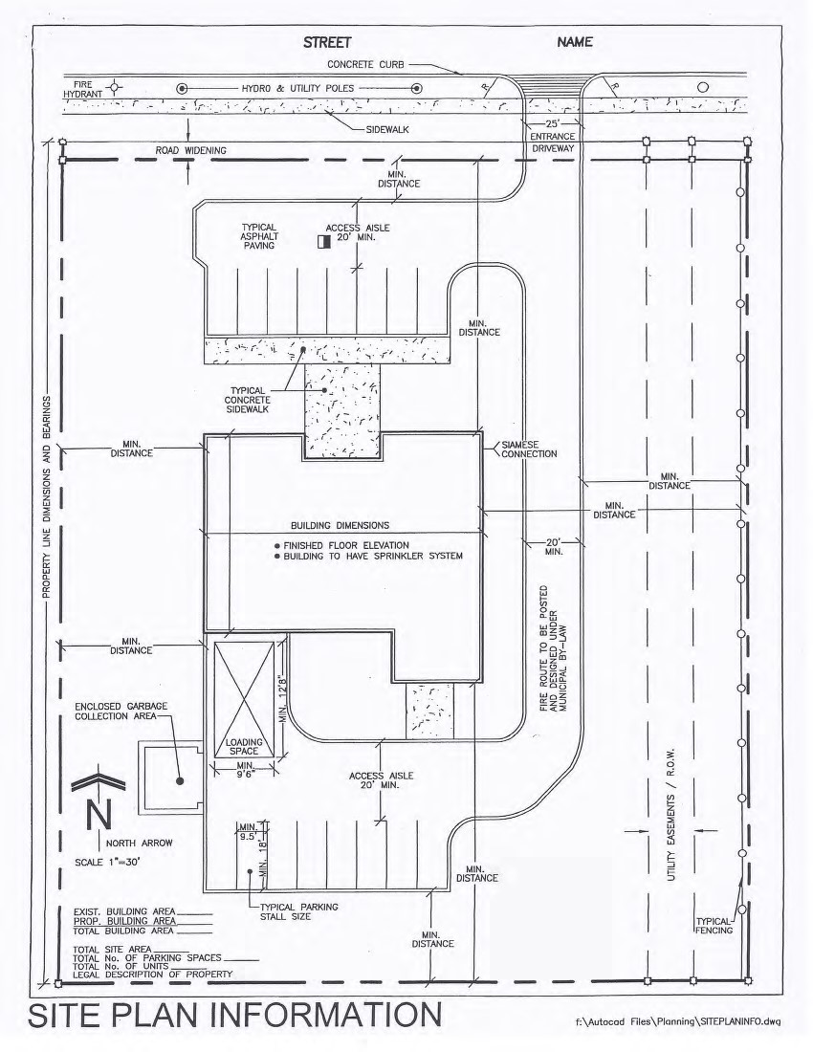
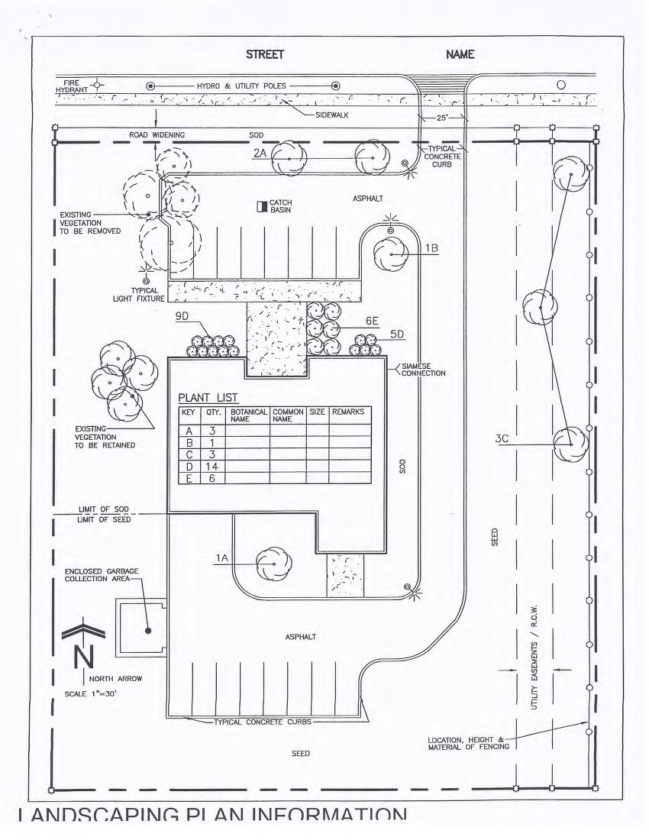
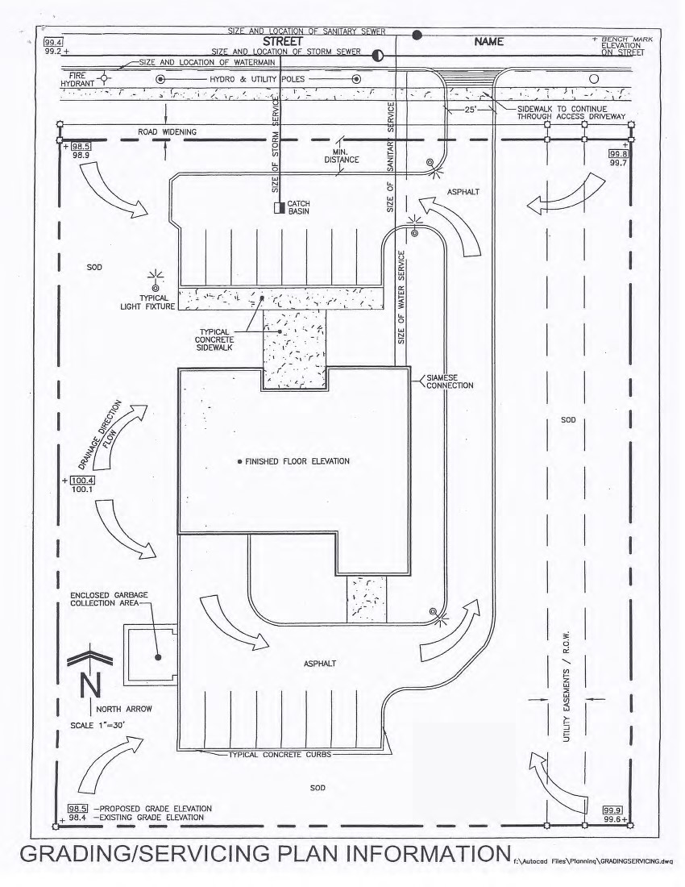

FORM IN WHICH LETTER OF CREDIT IS TO BE PREPARED

The Corporation of the Town of Deep River
100 Deep River Road
Deep River, ON K0J 1P0

Dear Sir/Madam,

Re: Letters of Credit for Site Works
(Name of Owner)
(Street Address)
(Legal Description of Property)

Pursuant to the request of our customer, (Owners Name) we the undersigned, The Bank of (Bank Name) hereby establish an irrevocable letter of credit in your favour in the total amount of (Written Amount)($_____) which may be drawn on by you to the extent required at the discretion of the Town of Deep River for the proper completion of the Site Plan Control Agreement conditions of said agreement covering a site situation on (Street Address and Legal Description) and known as Site Plan No. SP-(Site Plan Number).

Drawings under this letter of credit shall be in the form of a written demand for payment by the Corporation of the Town of Deep River.

The amount of this credit may be reduced from time to time, as advised by notice in writing given to the undersigned from time to time, by the Corporation of the Town of Deep River.

It is understood that this obligation is between the Bank of (Name of Bank) and the Corporation of the Town of Deep River and any notice referred to in the preceding paragraph shall not be used for any other purpose than herein set forth.

This letter of credit will continue to (Expiry) and will expire on that date and you may call for payment of the full amount understanding this letter of credit at any time up to the close of business on that date. It is a condition of this letter of credit that it shall be deemed to be automatically extended for one year from the present or any future expiration date hereof, unless sixty days prior to any such date, we shall notify you in writing by registered mail that we elect not to consider this letter of credit renewed for any such additional period.

Upon receipt by you of such notice, you may draw hereunder by means of your demand accompanied by your written certification that the amounts drawn will be retained and used by you to meet obligations incurred or to be incurred in connection with the above agreement; further, that you will release any amount not required by you to the Applicant.

For the Bank of (Name of Bank) ___________________________________________
Authorized Signature

