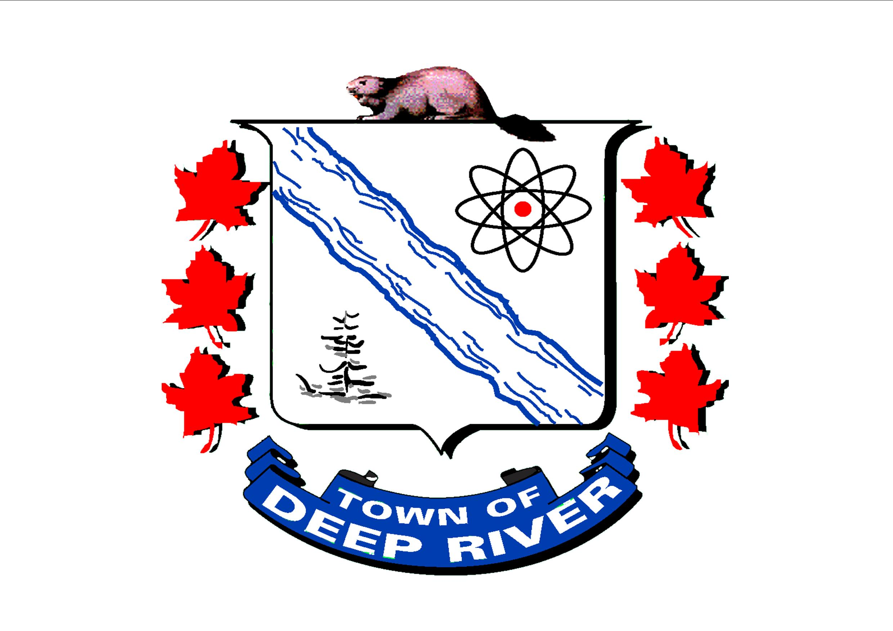

Casual/On Call School Crossing Guard

The Town of Deep River is looking for candidates who are interested in serving their community while earning extra income as a casual School Crossing Guard. This is fun, active and outdoor work performed only on school days. School Crossing Guards work with our Community at designated locations to assist Deep River’s school children in getting safely to and from school.

This a casual/on call position covering vacations, holidays and sick days.

The physical aspects of this position include standing and walking for prolonged periods of time while carrying a small stop sign, working in the heat, cold, rain and snow.

Applicants should possess strong customer service skills and a safety conscious attitude, applicants will need to be available September to June, Monday to Friday in the early morning and late afternoon. Upon being offered the casual/on call School Crossing Guard position, new hires must submit a criminal records check including a vulnerable sector search at their own expense.

The hourly rate for this position is $15.00

Application, including cover letter and complete resume of qualifications may be submitted to the undersigned:

Confidential and Private: School Crossing Guard
100 Deep River Road, P.O. Box 400
Deep River, ON K0J 1P0
Email: michelle.russell@deepriverpolice.ca

Thank you for your interest in the Town of Deep River. Only applicants selected for an interview will be contacted. Accessibility accommodations are available for all parts of the selection process. Applicants must make their needs known in advance. Information collected will be managed in accordance with the Municipal Freedom of Information and Protection of Privacy Act.

